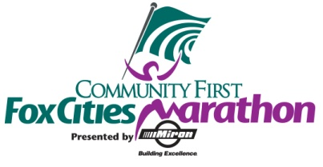
Half Marathon All Time Performance List (Men)
Place | Name | Time | Year
1 | John Dewitt | 1:05:41 | 2013
2 | John Dewitt | 1:05:54 | 2016
3 | Tyler Sigl | 1:07:53 | 2008
4 | Jason Ryf | 1:08:17 | 2006
5 | Dan Sutton | 1:08:46 | 2014
6 | Mark Manz | 1:08:47 | 2004
7 | Mark Manz | 1:08:49 | 2001
8 | Eamon McKenna | 1:08:54 | 2005
9 | Brian Finnel | 1:09:01 | 2016
10 | Dan Sutton | 1:09:04 | 2015

Half Marathon All Time Performance List (Women)
Place | Name | Time | Year
1 | Wendi Ray | 1:16:04 | 2000
2 | Katie Howery | 1:19:24 | 2011
3 | Kelly Scheller | 1:22:35 | 2009
4 | Krista Cornelius | 1:22:44 | 2010
5 | Angie Paprocki | 1:22:52 | 2006
6 | Molly Sunderlin | 1:22:53 | 2005
7 | Jenna Southworth | 1:23:07 | 2013
8 | Shannon Braun | 1:23:12 | 2009
9 | Annette Jadin | 1:23:14 | 2000
10 | Angie Voight | 1:23:38 | 2008

